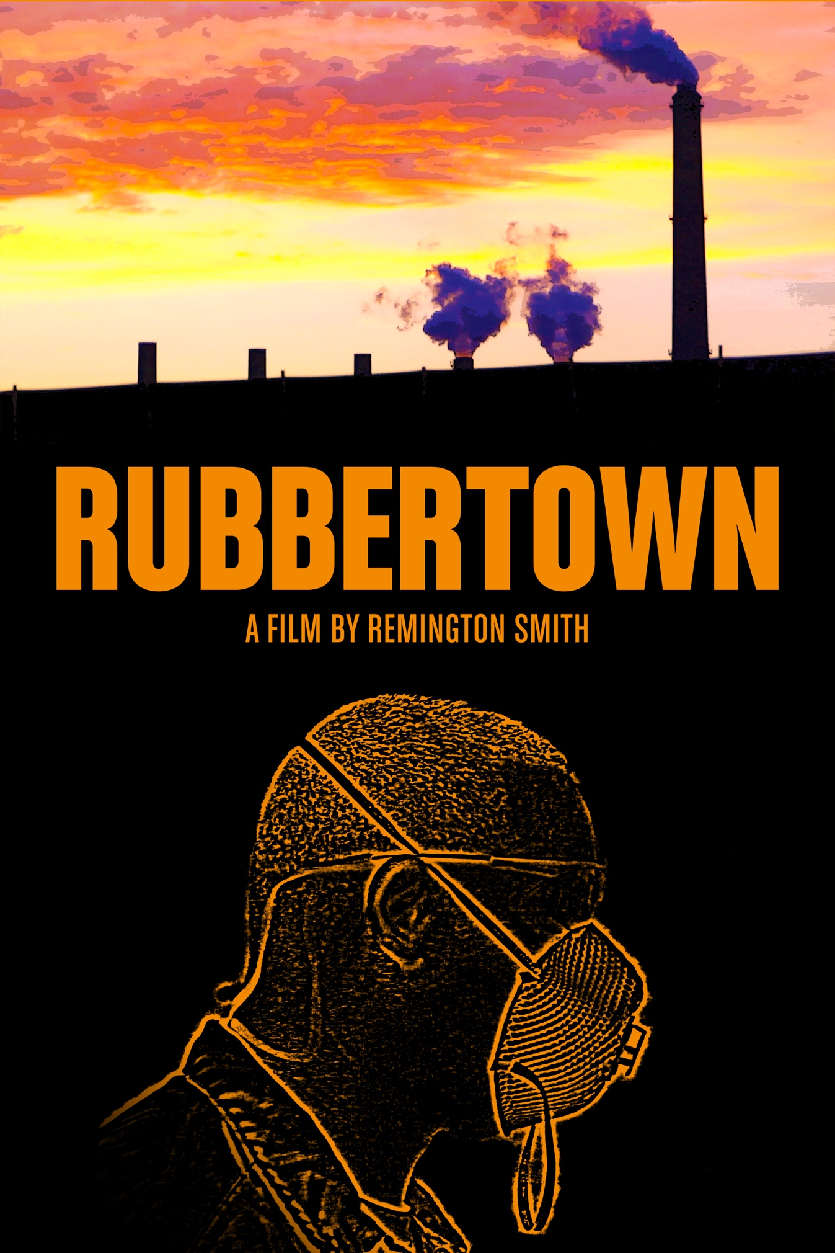Title: Rubbertown
Runtime: 53min
Year of Completion: August 2015, shot 2013-2015
Format: HD
Language: English
Website: www.rubbertownfilm.com
Contact: remington@rubbertownfilm.com // 859-229-8090
Credits
Director/Producer: Remington Smith
Associate Producer: Joshua Yates
Editor: Remington Smith
Cinematographer: Remington Smith

LOGLINE:
A woman struggles to move her entire house to another county after years of living near hazardous chemical manufacturing plants, a coal burning power plant, and a toxic landfill.
SYNOPSIS:
Rubbertown is Louisville, Kentucky’s neighborhood of heavy industrial manufacturing plants, and is located near a coal burning power plant and a toxic landfill site. These facilities are adjacent to residential neighborhoods.
The documentary Rubbertown follows Louisville, Kentucky resident Monika Burkhead as she tries to move her entire house to another county after suffering through years of regular leaks, spills, and occasional explosions at the nearby facilities, alongside fellow residents reporting higher rates of cancer and respiratory illnesses.
Part Studs Terkel-style oral history, part travelogue-from-hell, Rubbertown mixes traditional documentary storytelling techniques with exploratory POV expeditions, weaving together an examination of the environmental, political and social conditions affecting residents of Rubbertown. Through Monika’s house-moving narrative and the parallel story of Charles Pope, the film presents the perspectives of individuals varying in race, class, and regional affiliation, all within Louisville’s borders. The film’s diversity reflects Louisville’s particular combination of spaces, with urban areas closer to the city occupied by African-Americans, and white residents in rural areas further from the city center. In exploring these spaces through a POV lens and falling into impromptu conversations, Rubbertown offers a unique documentary experience—one that invites audience members to explore the issues for themselves, and sparks an interest in what’s going on in their own backyard.
DIRECTOR’S STATEMENT:
Dear Viewer,
Rubbertown was never meant to be a documentary. After doing research about this area of my hometown in Louisville, KY, I figured the environmental, racial, corporate and class elements would make for a harrowing fictional drama about the real dangers of living near these chemical plants. I shot enough documentary footage to put together a 20min short film, Beneath These Trees, and thought I'd use it to fundraise for the fiction film.
But when I showed the short to filmmaking colleagues, they encouraged me to make it a feature. It took some prodding, but eventually I folded. Once Monika Burkhead told me she was trying to move her entire house on a truck to Spencer county, I found the spine of the documentary.
So I walked around exploring these spaces that people on the highway or living in the suburban, white east end of town rarely see, conducting impromptu interviews with people I met. Then I began following Charles Pope who, as a black man living closer to the city, offered a different regional and racial perspective from Monika's about the same environmental issues. By the end of production, the film had developed an interesting mix of formats: I would do a standard interview setup in Monika’s home, then meet a man living on a toxic landfill site. It was a range of encounters you could only accomplish by going off the beaten path.
Part oral history, part travelogue-from-hell, Rubbertown is the byproduct of a lot of research, long afternoon chats, and getting into a little bit of trouble. Seeing the response from people who watched the early drafts made all of this work as a lone shooter, director, producer, and editor worth it.
Rubbertown is not intended to be a total encapsulation of the problems facing the residents living near the Rubbertown area. There are plenty of newspaper articles that will provide you a clinical perspective, with all the data you could want. But without an understanding of the lives these people live and the actual proximity of these chemical plants to people's homes (literally across the street in some cases), all the data in the world doesn’t paint the full picture either. This film allows viewers to visualize, on a more visceral level, what it means to live near a superfund site or near a coal burning power plant.
So thank you for watching the film. My hope is that you see this and do your own digging, your own afternoon wanderings, to see what might be in your own backyard.
Who knows what you'll find.
Sincerely,
Remington
ABOUT THE FILM’S PRODUCTION:
In 2010, Rubbertown director and producer Remington Smith read an article about coal ash ponds in the LEO, Louisville, Kentucky’s alt-weekly newspaper. “I read about this proposal to build a coal ash pond that they described as several stories tall. So, I’m like, ‘what the hell is that?’ And I look into it and they’re basically holding ponds for leftovers from burning coal for power, heavy metals, all sorts of toxic stuff. And there was one built in Tennessee,” Remington recalls. “And in 2008 the earthen dams that created this pond failed, practically wiping out the nearby neighborhoods under carcinogenic sludge. Once I learned about the ash pond, the other chemical companies in the area, and the higher cancer rates for people living around this stuff, I knew I had to make a film about it.”
Originally the film was going to be a fiction film about a family trying to move away from the chemical plants in Rubbertown. However, once documentary footage was collected to raise funds for the project, the material quickly caught the attention of fellow filmmakers who encouraged Remington to make a feature documentary.
Production began in earnest during the summer of 2013, with Remington focusing on Monika Burkhead, who was moving her entire house to another county to escape the environmental risks of Rubbertown. Filming also followed Charles Pope, who worked for the city’s Vacant Lots division of Public Works and whose mother died from a cancer doctors connected to her proximity to Rubbertown.
For these shoots, director Remington Smith wasn’t just directing, but also camera operating and monitoring sound. By stressing a pared down approach to production, Remington wanted to maintain intimate engagements during interviews - and keep a low profile when shooting chemical companies. “This film was shot on borrowed equipment over the course of several years, so the budget was whatever I was putting into it. But I also purposely didn’t want any interviews in a studio. For some projects I think it’s great, but for this, I wanted to be with people in their homes, something more intimate and similar to the kinds of conversations we all have with friends and family.”
With this production practice, Remington built such a strong rapport with Monika and Charles that the final edit received their approval. “It seems weird to me that I would shoot hours of footage of people and not share a rough draft with them. They’ve invited me into their lives to make this film, so the least I can do is invite their thoughts before it’s released.”
The film as a whole was produced as a way of building community connections, and using one’s talents to uplift the voices of others. It was also a way to show, instead of tell, the environmental concerns of Rubbertown residents. “The modern highway system has been a mixed blessing, because there are entire segments of a city you’ll never even see. You literally drive over these areas, not even driving through a place like Rubbertown where you would otherwise smell the chemicals that might be leaked or purposefully released into the air. So this was also a film about providing a visual for what these places look like and just how close they are to people’s homes.”
Smith decided to make a documentary rather than a fiction film with the goal of making a greater impact. “There’s time to make a fiction film if I still feel up to it. But I thought a documentary might have a better shot at instigating some change in the way the city and the EPA have regulated these companies.”

THE FILMMAKERS:
Remington Smith
Director, Producer, Editor, Cinematographer
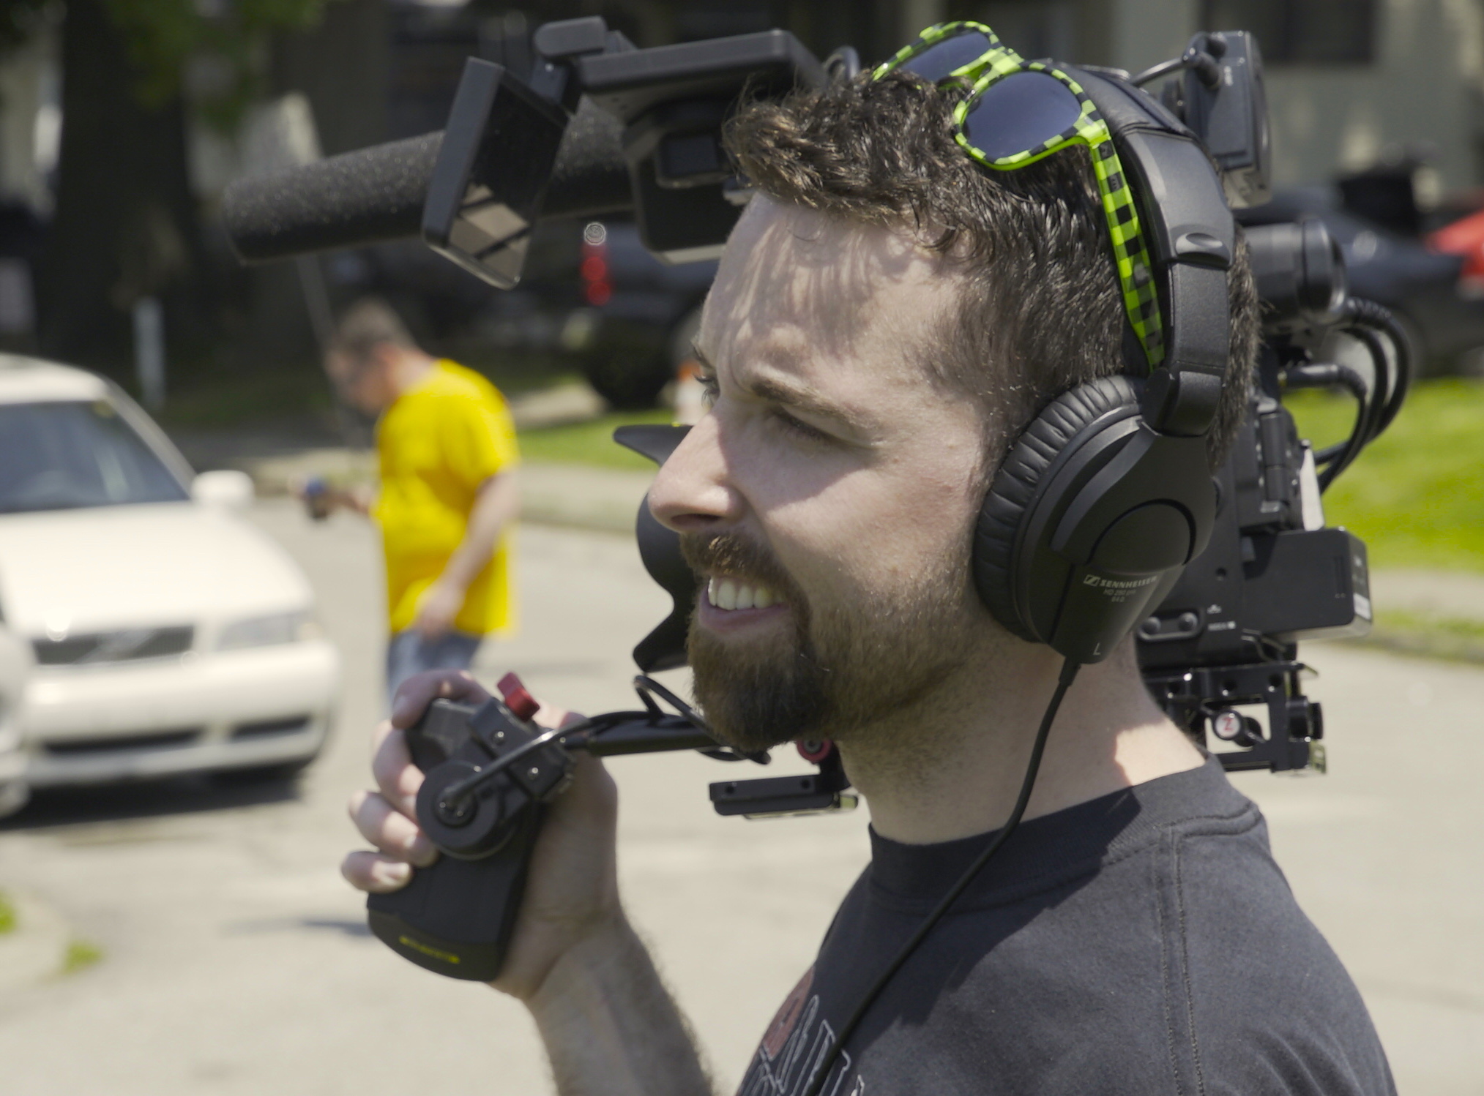
Remington Smith is an award winning filmmaker from Louisville, Kentucky who is currently a Visiting Assistant Professor for the University of Louisville teaching film production. He earned his BA in History from the University of Louisville, where he made his first two short films, before attending the University of Edinburgh. At Edinburgh he earned his Master's in Film Studies, writing his thesis on "Unsafe Horrors: A Critical Analysis of Horror Cinema, Torture Porn and the Unsafe Horror Film.” There he produced his first documentary short, Last Good Thing, about the emotional toll of a Scottish gravedigger’s occupation. In 2014 he earned his MFA in Film and Video Production from the University of Iowa, where he taught undergraduate students as a Primary Instructor in film and video production.

His latest short film, The Woods, won Best Horror Short at the 2015 Louisville Film Festival and and the Silver Award from the Spotlight Horror Short Awards, and his film Dawn of the Living was awarded Best Film and Best Actor by the Edinburgh Movie Production Society in 2010. His films have screened across the U.S., in the U.K. and Israel, at venues including the Landlocked Film Festival, Snake Alley Film Festival, Louisville's International Festival of Film, Speechless Film Festival, River's Edge Film Festival, Iowa Independent Film Festival, Edinburgh Movie Production Society and the Y'allywood Film Festival.
Rubbertown is his first feature length documentary. He is currently in pre-production on a feature length horror film entitled Land Lord, as well as a feature length documentary about the Kentucky Derby.
Joshua Yates
Associate Producer
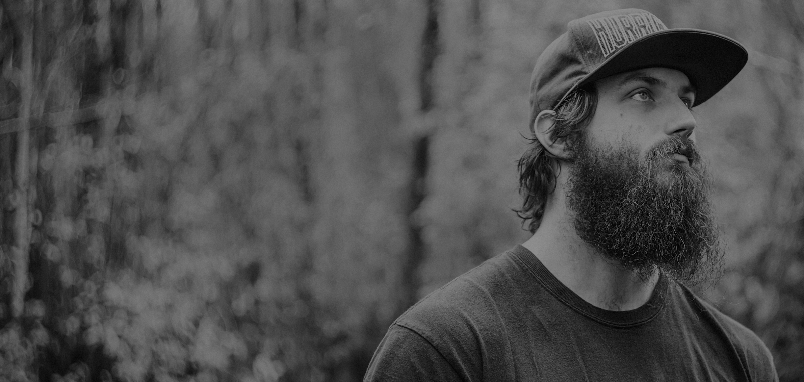

Currently a filmmaker in residence at the famous Columbia, SC filmhouse The Nickelodeon, Joshua Yates is the recent recipient of the Experimental Grit Award from the Indie Grits Film Festival for his film This is Yates. His work as a filmmaker has been screened around the world and he earned a Vimeo Staff Pick for his music video, Exodia. He served as cinematographer for Remington Smith’s award winning horror short The Woods, and Yates’ work on Rubbertown was crucial in crafting the film’s narrative flow and tone.
RUBBERTOWN: THE PLACE
Rubbertown is a neighborhood of chemical plants in Louisville, Kentucky that earned its name from the synthetic rubber plants occupying the space during World War II. Along the same strip of riverside real estate is a coal burning power plant and the Lee’s Lane Landfill, an EPA superfund site where over 300 companies from around the US have dumped hazardous materials, often undrummed, straight into the soil.
In 2013 NPR’s Louisville affiliate WFPL did a multi-program report about the health impact of living near Rubbertown; the report revealed higher lung and colon cancer rates than found among other Louisville residents. The area is also plagued by leaks, spills, and the occasional explosion, one of which, in 2011, killed two workers at Carbide Industries.

During the course of the film’s production, the LG&E coal burning power plant profiled in the film was closed to make way for a gas burning power plant. The EPA has renewed testing at the Lee’s Lane Landfill for hazardous gases seeping out of the ground, and there are proposals for a methane plant to be built within four miles of Rubbertown.
Several issues currently face the neighborhoods surrounding Rubbertown. The city’s Air Pollution Control District (APCD) does not provide 24/7 monitoring of odor and pollution reports, leading to reports of companies illegally dumping hazardous material during APCD’s off hours on weekends and evenings. The Lee’s Lane Landfill, an official superfund site cleaned up by the EPA near Monika Burkhead’s home, is not fenced off from the public and lacks clear signage on the walking/bike path nearby. Resultant ATV usage on the site threatens a clay topper meant to secure contaminants beneath the soil. Rates of cancer and respiratory illness are higher around Rubbertown, but with so many factories in one area, specifically linking one chemical from one plant to one person’s illness is difficult.

THE PARTICIPANTS:
Monika Burkhead
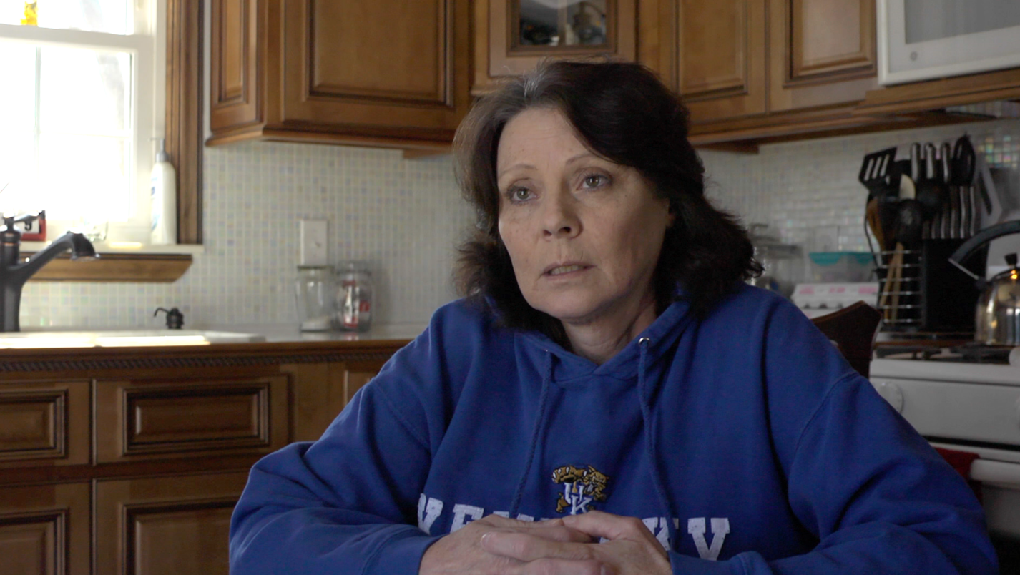
Monika Burkhead has been a resident of Riverside Gardens in Louisville, Kentucky since 1975. She became an environmental activist once she learned of the health risks of living in the shadow of LG&E’s smokestacks, the continued threat posed by the Lee’s Lane Landfill (where she has caught children swimming in a pond) and chemical plants nearby regularly having spills. Her daughter Jennifer developed a kidney stone disease, colitis and Crohn’s when she was 13, all of which Monika attributes to living in Rubbertown.

Charles Pope
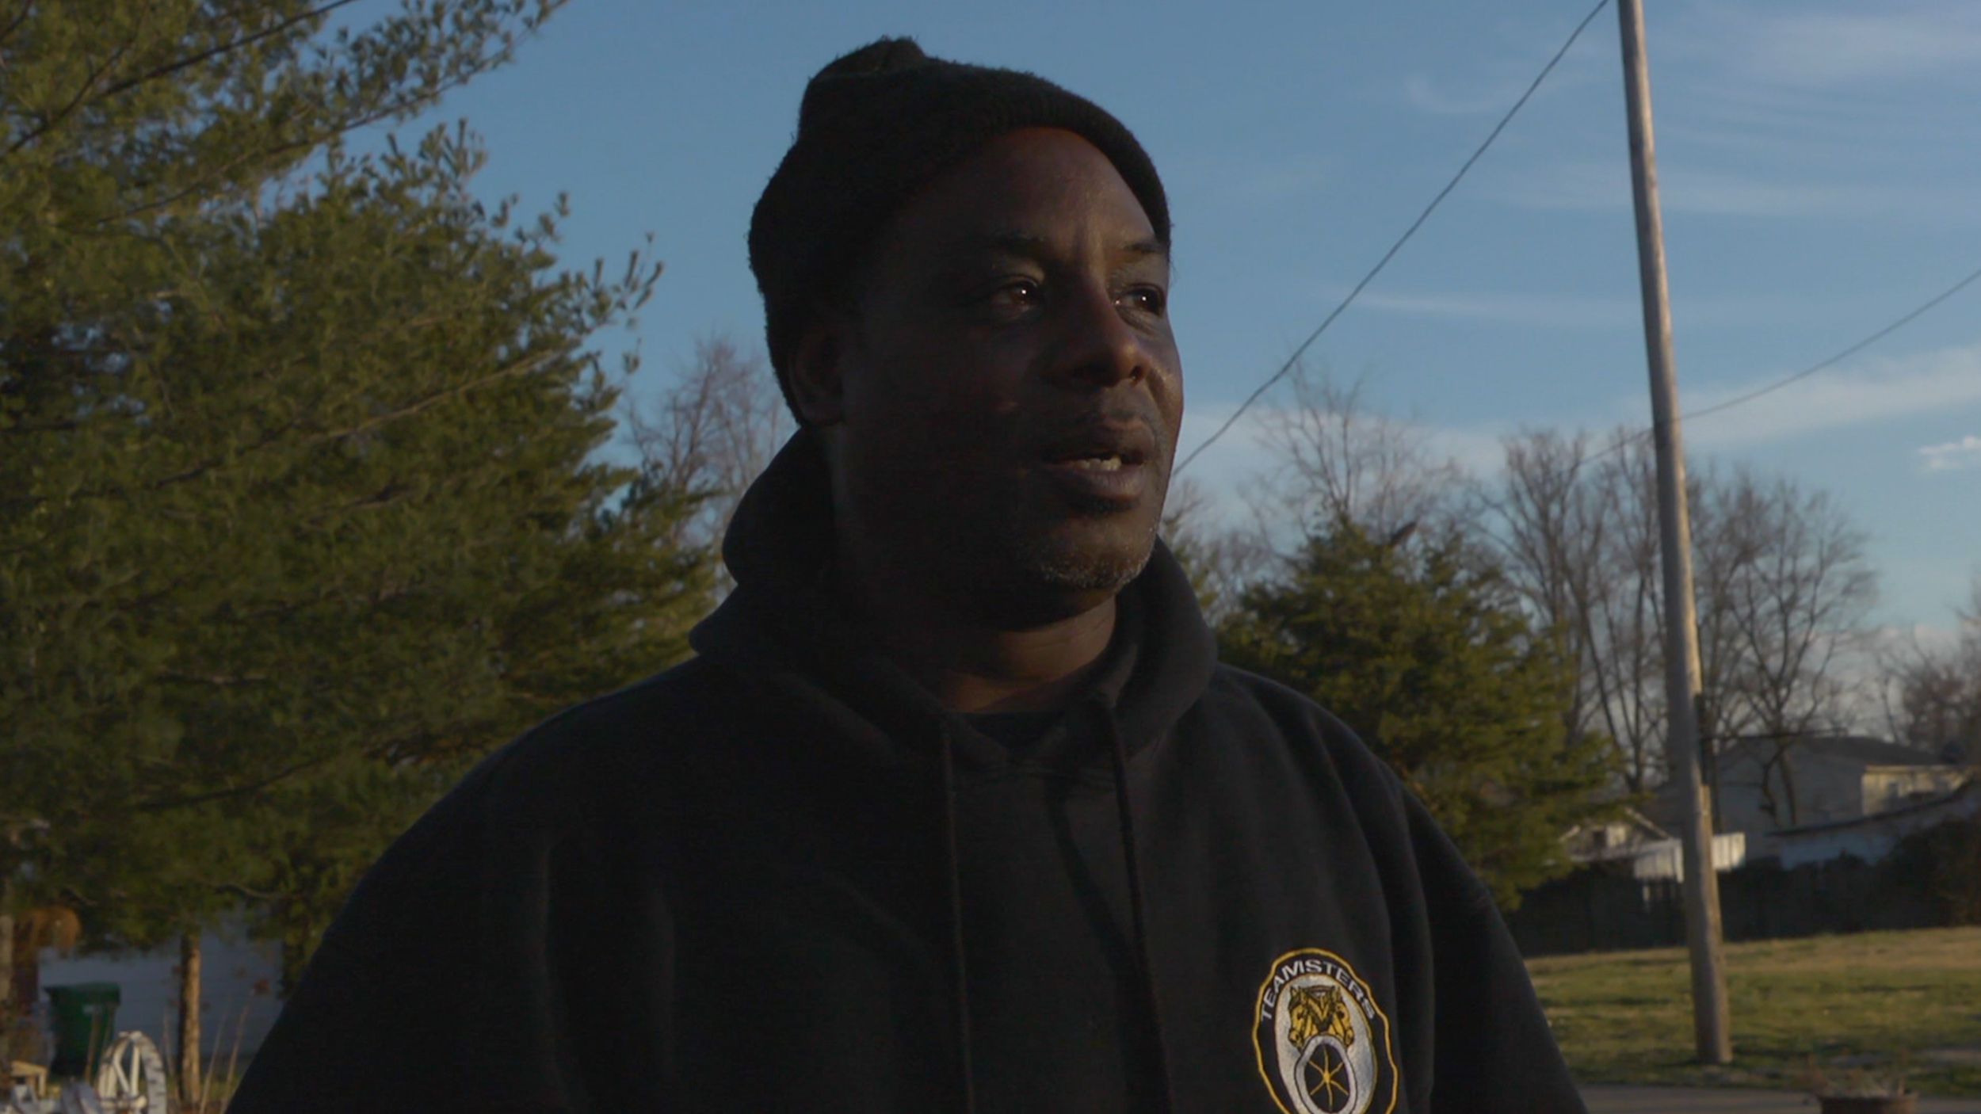
Charles Pope has lived on Louisville, Kentucky’s west side all his life. When his mother died of Bronchoalveolar lung cancer, doctors told him it was potentially linked to her proximity to Rubbertown. In 2003 he joined REACT (Rubbertown Emergency ACTion) with Eboni Cochran, and began taking air samples and organizing the community to fight pollution in their neighborhood.

